**Banking System Database**

**February 21, 2020**

**Kevin Huynh**

**Table of Contents**

**Section I …………………………………………………………………………………………………………………………………………Page 3**

**Section II ………………………………………………………………………………………………………………………………………Page 4**

**Section III ……………………………………………………………………………………………………………………………………Page 5**

**Section IV ………………………………………………………………………………………………………………………………………Page 6**

**Section V …………………………………………………………………………………………………………………………………………Page 9**

**Section VI ………………………………………………………………………………………………………………………………………Page 10**

**Section I: Project Description**

My database system is about a banking system. There will be a User entity along with an Account entity containing Bank Accounts. The Bank will have multiple branches, each with a manager. Inside each branch, there will be bank tellers handling clients coming to either create accounts or process transactions. There will also be ATM’s inside these branches for basic transactions if the bank tellers are unavailable.

**Section II: Use Cases**

1. John Smith was finally hired for his first job and he was thinking of creating an account at a branch of the XYZ World Bank. The main bank of XYZ World Bank has many branches. In the many branches, the manager oversees the employees in that branch.
2. Walking in, he can see ATMs in the surrounding area, along with bank tellers dealing with clients. At the bank teller, he finds out that, within the user account, the XYZ World Bank offers two types of bank accounts: savings account and checking account. To create any account, he had to provide all sorts of personal information and he even had to option to introduce other owners.
3. John decided to finally to tell the bank teller to create both a checking account and a savings account for him. He receives a debit card containing a 16 digit number, a 3 digit CVV number, and an expiration date.
4. With the debit card, John Smith can perform transactions, which are processed by bank tellers, with other clients with his bank account. There are many methods of transactions, including checks, transfers, deposit, and withdrawal.
5. The debit card is for transaction with the ATM. XYZ World Bank offers an interest of 0.06% APY (annual percentage yield) on the savings account. The savings account has a “withdrawal limit” of six times per month.
6. When John Smith went to try out his new debit card, he realized that any transaction using his card affects only the checking account. The bank teller told him that he can transfer money from his checking account to his savings account and vice-versa.
7. When John Smith finally received his first paycheck, it was deposited directly into his account. John Smith found out that he can also deposit cash into his parents’ accounts.

**Section III: Business Rules**

1. Main bank has multiple branches.
2. Employees work at a branch.
3. Manager manages a branch.
4. ATMs are located inside a branch.
5. One account can contain multiple bank accounts.
6. Clients can transact with other clients.
7. Bank tellers can create accounts for clients.
8. Bank tellers can create bank accounts for clients.
9. An account can be owned by multiple clients.
10. Bank Tellers processes checks.
11. Clients can own multiple debit cards.
12. Debit cards are connected to one checking account.
13. Debit cards can perform transactions with an ATM.
14. Checking account can transfer money to savings account, and vice versa.

**Section IV: Detailed List of Main Entities, Attributes, Keys**

1. Bank

* bank_id: PK

* bank_name: multivalue

1. Branch

* branch_id: PK

* manager_id: FK

* main_bank

1. Employee

* employee_id: PK

* name: multivalue

* branch_id: FK UK

* age: derived

* dob: composite

1. Manager

* manager_id: PK

* emmployee_id: FK

* name: multivalue

* branch_id: FK UK

* age: derived

* dob: composite

1. Bank Teller

* teller_id: PK

* employee_id: FK UK

* name: multivalue

* branch_id: FK UK

* age: derived

* dob: composite

1. User

* user_id: PK

* name: multivalue

* dob: composite

* age: derived

1. Client

* client_id: PK

* user_id: FK UK

* name: multivalue

* dob: composite

* age: derived

1. Account

* account_id: PK

* username: UK

* password

* teller_id: FK

1. Bank Account

* bacc_id: PK

* balance

* teller_id: FK

1. Checking Account

* checking_id: PK

* bacc_id: FK UK

* balance

* teller_id: FK

1. Savings Account

* saving_id: PK

* bacc_id: FK UK

* balance

* APY

* teller_id: FK

1. Transfer

* transfer_id: PK

* checking_id: FK

* saving_id: FK

* amount

* transfer_method

1. ATM

* atm_id: PK

* balance

* branch_id: FK

1. ATM Transactions

* atmTrans_id: PK

* atm_id: FK

* card_number: FK

* amount

* transact_type

1. Debit Card

* card_number: PK

* CVV

* pin

* expiration_date

* checking_id: FK

1. Client Transaction

* clientTrans_id: PK

* client_id(to): FK

* client_id(from): FK

* amount

* transact_type

1. Checks

* check_id: PK

* client_id(to): FK

* client_id(from): FK

* amount

* teller_id: FK

**Section V: Entity Relationship Diagram (ERD)**

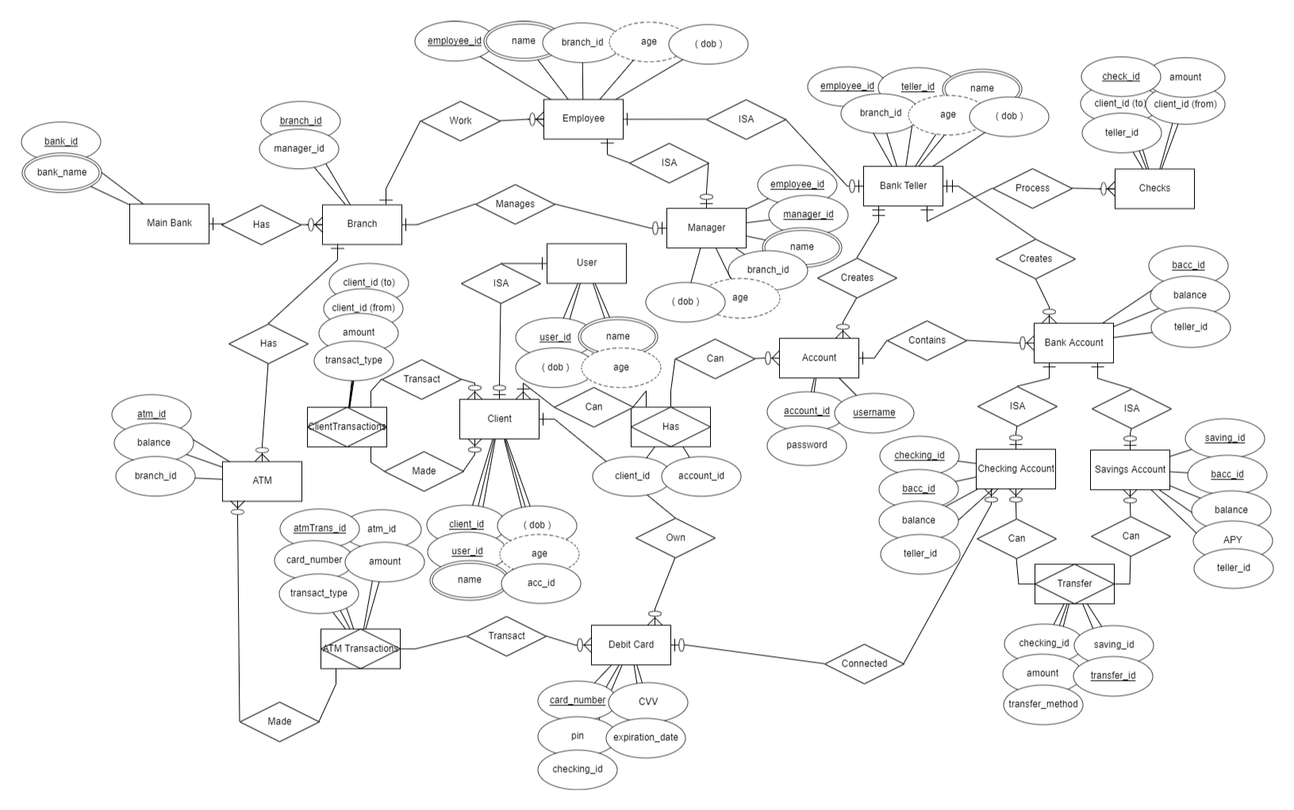

**Section VI: Testing Table**

|  |  |  |  |  |  |  |
| --- | --- | --- | --- | --- | --- | --- |
| **Rule** | **Entity A** | **Relation** | **Entity B** | **Cardinality** | **Pass/Fail** | **Error** |
| 1 | Bank | Has | Branches | 1-to-M | Pass |  |
| 2 | Employee | Works | Branch | M-to-1 | Pass |  |
| 3 | Manager | Manages | Branch | 1-to-1 | Pass |  |
| 4 | Branch | Has | ATM | 1-to-M | Pass |  |
| 5 | Account | Contains | Bank  Account | 1-to-M | Pass |  |
| 6 | Client | Transact | Client | M-to-N | Pass |  |
| 7 | Bank Teller | Create | Account | 1-to-M | Pass |  |
| 8 | Bank Teller | Create | Bank Account | 1-to-M | Pass |  |
| 9 | Account | Owned | Client | M-to-1  M-to-N | Fail | Clients can create multiple accounts |
| 10 | Bank teller | Process | Checks | 1-to-M | Pass |  |
| 11 | Client | Owns | Debit Card | 1-to-M | Pass |  |
| 12 | Debit Card | Connected | Checking Account | 1-to-M | Pass |  |
| 13 | Debit Card | Transact | ATM | M-to-N | Pass |  |
| 14 | Checking Account | Transfer Money | Saving Account | M-to-N | Pass |  |